Wilberforce Pendulum modelling PHYS1201 ASE project, 2022

By Campbell McTernan and Aditya Singh Tejas

Date 5/ 11 /2022

**1.0 Abstract**

This report details the creation and simulation of a MWP (Modified Wilberforce Pendulum [should abbreviation be changed back]) to determine and analyse the accuracy of Euler-Lagrange approximations to a physically designed project. This investigation had modified the original design by allowing the pendulum to move in a traditional swinging motion, and also placing the system on a free support. The model was first tested with a naïve horizontal cylindrical weight1 which ultimately discarded due to erroneous wobbling2. The pendulum weight design was then altered3, which greatly reduced error. To model the pendulum, an experimentally validated model and trial-based best fit model were used. Overall, the trial model proved to be a more successful prediction of the pendulum’s motion. The average discrepancy between the best fit model and the video was _ cm 4 while the validated simulation had a discrepancy of _ cm 5. This shows that the constructed Wilberforce Pendulum was far more complex than point mass Lagrangian calculations can predict, showing that the use of rigid body components and complex friction is necessary to model this behaviour.

**2.0 Introduction**

**2.1 Aims and Hypothesis**

The overall aim of this experiment was to analyse the MWP both by using theoretical modelling and experimental footage, but this can be more explicitly broken down into two separate aims:

1. To build a reliable and precise Wilberforce pendulum which could exhibit traditional characteristics, but also incorporated the key alterations
2. To simulate the modified system, and compare it with the physical model

It was expected that theoretical modelling would be visually similar to the physical footage, and furthermore that the simulation could predict the motion of the model to a few centimetres. Furthermore, the theoretical model’s accuracy was anticipated decrease exponentially with time, as pendulum systems with multiple articulated components often greatly in movement due to even the smallest variation in starting conditions. Lastly, measured constants were expected to be inferior to trial based estimations for the model, as they could account for unknown friction or uncertainty in measured values.

**2.2 Traditional Pendulums**

Pendulums are quite a common tool for the simulation of simple physics models as they provide a simple system which is reproducible and compact, while easily isolating individual physical phenomena for study. A simple pendulum is usually constructed by hanging a heavy point mass like a ball from a rigid rod or string of negligible mass. Demonstrated in Figure (1.1), the mass will always be constrained to motion in circular arc by the rod, and experiences force towards the equilibrium point created by the difference rod tension and gravity. This eventuates in swinging motion with the highest velocity at the equilibrium point, and zero velocity at each maximum.

Figure (1.1) Simple pendulum [include force diagram on ball if we have the time R2

The traditional Wilberforce pendulum was first described by the physicist Lionel Robert Wilberforce in 1896R3, and has motion governed not by gravitational potential, but instead by the tortional and extension properties of the spring. If the mass is released at any distance from the natural hanging length, the spring will provide a restoring force towards the natural state due to extension potential. This force will naturally cause the spring to wind and unwind as it moves which creates tortional potential in the direction of the spring coils which will cause the mass to rotate. This rotation will cause the spring to wind and unwind, contracting and expanding the length of the spring to cause more extension potential. Hence, the system demonstrates simple coupled oscillators and if calibrated correctly can alternate between purely vertical and rotational motion. Demonstrations of this apparatus and similar variations can be found from a variety of sourcesR4, R5, R6.

Figure (1.2) Traditional Wilberforce pendulum

**2.3 Modified Wilberforce Pendulum**

To extend the understanding of Wilberforce Pendulum phenomena and modelling, this experiment uses a novel system with two altercations:

1. A free support of negligible mass was added to the top of the pendulum, and a frictionless rail was provided for it to slide across.
2. The free support was designed to accommodate regular swinging motion like a simple pendulum.

Figure (2.4) MWP with specified named variables

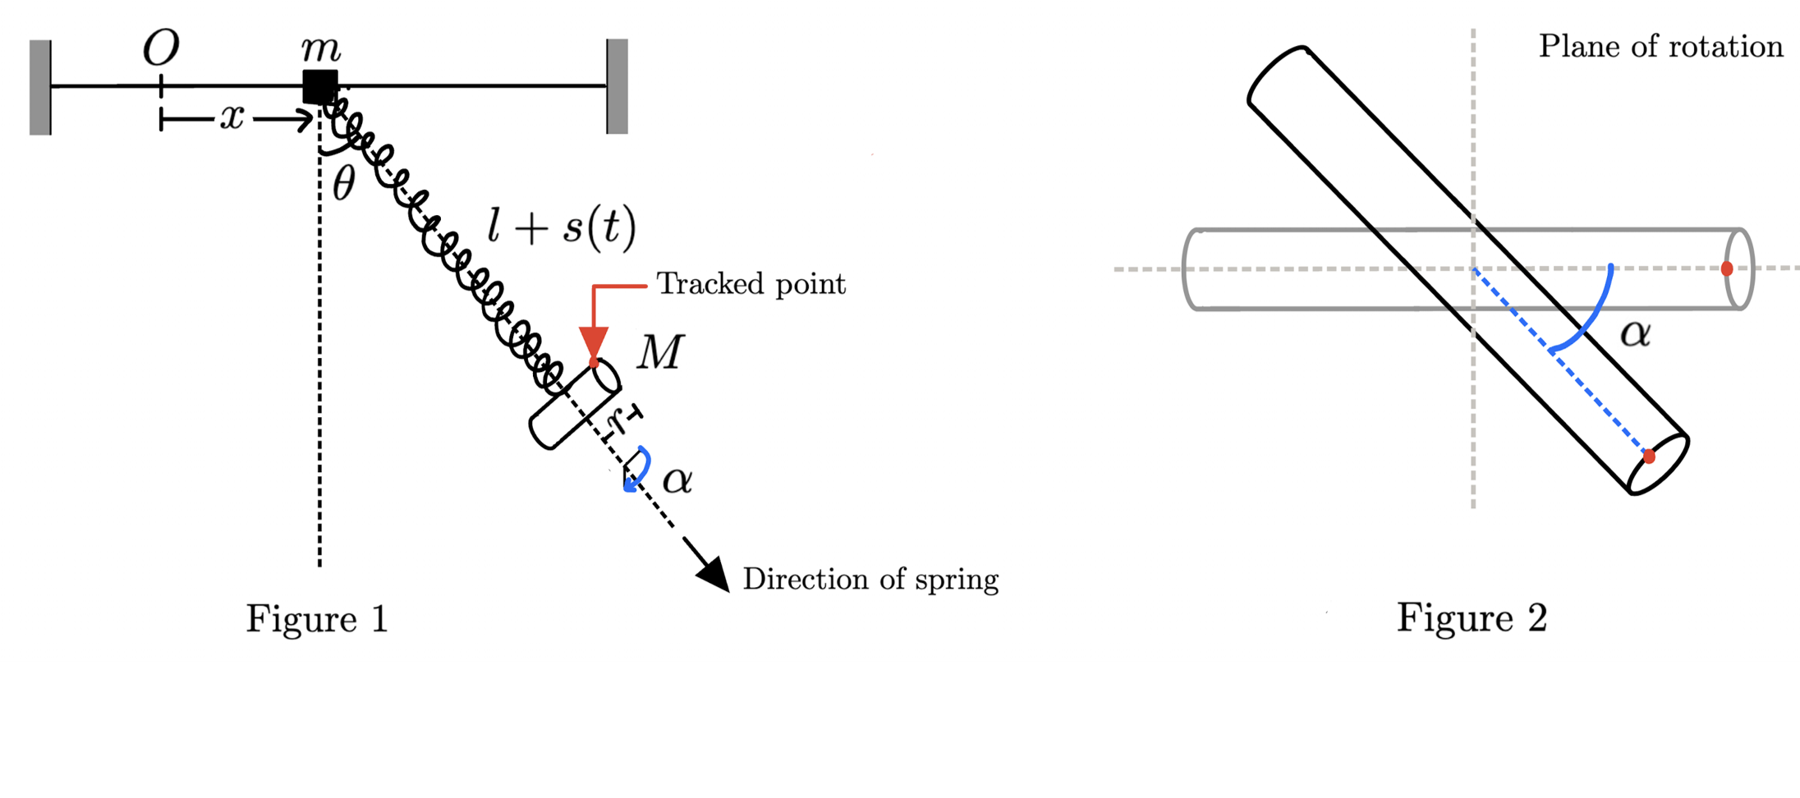

(maybe add what each variable means)

These modifications provide significant changes on the forces and potential present on the system, and to our knowledge this system has never been modelled before. As the pendulum now resides on a free support, the motion is no longer constrained to a circular arc. This experiment assumes that the free support mass is much less than the total system, and the spring has negligible mass. Hence, the free support position will be subject primarily to the cylindrical mass as the entire system will move with the centre of mass. Overall, this change will further distribute the energy of the system as the free support can hold a velocity, so when considering the pendulum’s motion from the springs frame of reference, the motion is damped.

The implementation of swinging, simple pendulum motion drastically changes the motion and predictions of the traditional Wilberforce system. Similarly to the simple pendulum, the mass will now experience a force towards the equilibrium point directly below the centre of mass due to gravity. Hence the system will behave far more unpredictably, with a far greater range of motion. For a traditional Wilberforce system the cylindrical mass will only move vertically, so Lagrangian equations for point masses will be functionally indistinguishable from rigid body considerations, disregarding air resistance. In contrast, as the MWP has a complicated range of motion, multiple joints between components and a spring which is not strictly rigid along its vertical axis [have spring diagram, label vertical axis, direction of coils etc] rigid body considerations are necessary.

One such example of this is the distribution of mass in the MWP bob [label mass bob]. As picture in the diagrams, weighted protrusions jut from either side of the central cylinder. This distributed the concentration of mass, and changed the moment of inertia.

**2.4 Theory**

Assumptions

Due to the way the experiment was conducted

* The free support mass was much lighter than the bob mass
* The cylinder mass was much larger than the protrusion mass
* The Bob mass moment of inertia could be approximated by two intersecting cylinders
* [Potentially the spring coil diameter is far less than the strand coil diameter]

Due to negligible friction/ soft body properties

* The spring was rigid (could not bend side to side during motion) and massless
* The free support and connection to the rails provided little friction
* The bob cylinder had an even density [mention filled with nails and clay]
* The frame was completely rigid and unmoving
* The wobbling effect of the bob and associated energy lost was negligible
* The friction of the entire system can be approximated by a blanket energy potential in the Lagrangian
* The tracking interface was completely accurate for selection of points

Modelling

[just use notebook for this part]

To model the Wilberforce pendulum, we will use Euler-Lagrange equations, which require calculation of the Lagrangian:

Kinetic Energy

As the entire system is free to slide along a rail, the whole system can obtain a common velocity and thus kinetic energy. Defining $\dot{x}$  to be the velocity of the system in the $x$ direction, we have . Furthermore, the cylinder will have velocity relative to the system and rotational energy dependant on the rotational velocity given by and .

Hence, the total kinetic energy of the system is , so

Potential energy

We know that a spring with spring constant and stretch length has a spring potential . We also know that the torsional potential of the spring is . Since these potentials are coupled, we furthermore have the potential which represents the shared energy held during the transfer of energy between and in the system. As there are only two coupled components of potential, this relationship is linear and proportional to and . Thus, assume where is some constant. Finally, as this Wilberforce experiment has been made unique by the inclusion of traditional swinging pendulum motion, we also have gravitational potential .

Thus, the total kinetic energy of the system is , so

**3.0 System Design**

**3.1 Design Process**

Initially, the project was inspired by a presentation on Auto parametric resonanceR7 and a document on the Wilberforce Pendulum by WolframR8. Figure (3.1) displays this initial model for a fixed support, named Model 1. Hence, the use of a cylindrical weight perpendicular to the spring was used, with nuts positioned on either side to manually adjust the moment of inertia of the mass.

The main problem with the physical build was sourcing a spring. This experiment required a specific type of mass with little practical use. It was decided that the experiment frame would be roughly 1m wide, and 0.5m high. Thus, the spring would have to be around 20cm when hanging, and have the ability to stretch under a load of 100-500g to double its length. Furthermore, the weight must be able to spin noticeably. This translates to a long spring with low spring and tortional constants.

During construction, no spring could be found with the required length and constant properties, as the spring was too small with high constants. This resulted in the choice of using large threaded bolts of solid iron. This had the advantage of using helical nuts screwed onto the bolts approximating cylinders, and allowing for the moment of inertia to be adjusted. The bolts was filed, cut, and soldered onto the bottom of the spring for a firm point of contact. To secure the spring to the free support, a hollow metal sphere with a screw attachment was secured via a nut and hot glue to the spring.

The frame was created using plywood and wooden beams screwed tightly together, with adjustable metal feet at the bottom to carefully calibrate how level the system was. Two thin metal rods were used as rails for the free support, as shown in Figure (3.3)

Figure (3.3) Side and front view of rail and free support system for Models 1 and 2

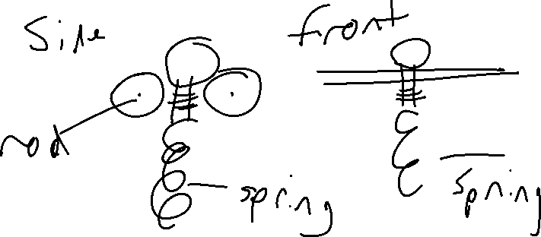

The initial project was then tested and filmed, shown in the results section, Figure (4.1) – (4.3). As shown in the demonstration of the traditional Wilberforce setup, the system behaves as is intuitively expected, with motion similar to _source2_R4 and _source3_R5. However, when testing this system with the modified arc motion, the model seems to experience an unintended “wobble”, or oscillation around the point of connection for the spring as displayed in Figure (3.1). This oscillation persisted over a number of attempts and starting positions. As this experiment is intended to be founded entirely on physics and Lagrangian principles solely based on point mass approximations, we believe that this substitution of a point mass for a cylinder, despite the use of moment of inertia is to blame for this discrepancy. As the wobble involves motion and kinetic energy, we concluded that the wobble was coupled with the system, and was essentially storing energy in an unexpected and unwanted fashion.

Figure (3.1) Wolfram initial inspiration R9

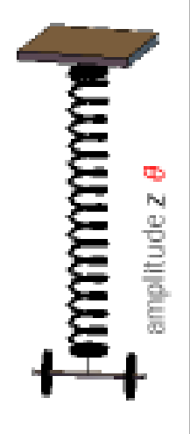

Ultimately, due to this unforeseen movement, we opted to entirely redesign the cylindrical mass and create Model 2, to be physically similar to _source2_R9 and _source3_R10, as shown in Figure (1.2). We believed that this solution would be more effective at minimising wobbling due to the distribution of mass. In Figure (3.1), the majority of the weight is skewed to each side. Thus, any slight wobbling from the apparatus causes high torque on the outer weights, and causes more movement and allocation of energy. In contrast, the design of Figure (1.2) centralises weight to provide a less substantial and stable wobbling motion. We conceded that this wobbling motion was erroneous but could not be stopped entirely. Later tests of this setup displayed far less wobble, and thus the design was accepted and used.

To construct Model 2, we decided to drastically increase the size of the [bob: decide naming convention] to facilitate the use of a longer spring with a much higher spring constant. The intention was to make the bob as heavy as possible for this intent. To made the bob heavy, a purple plastic cylinder was filled with nails and modelling clay, as these materials were in abundance and had high density. The total cylinder mass was 0.5kg, which was too little for the longer string. Thus, the size of the shorter spring was reduced, which decreased the rest length of the spring to optimal proportions. To match the protrusions demonstrated in _source2_, heavy metal bolts were added either side of the bob. Furthermore, a screw bit was attached to secure the bob to the spring. Thus, using the free support and frame from Model 1, combined with the shortened spring and a new bob Model 2 was created and used in the final experiment.

**3.2 Method**

Figure (3.2): Frame and diagram apparatus of our setup in clean black lines

[]

As detailed in Figure (3.2) and Section 3.1, design Model 2 was used for the collection of data. Model 2 construction:

The wooden pendulum frame was placed on a flat table with a white backdrop in a bright environment. The frame legs were calibrated such that the rails on the frame were perfectly perpendicular to the ground, as verified by a spirit level. The rails were then lubricated thoroughly before the free support was placed on them. The free support was attached firmly to the bob and spring, such that all joints were strictly rigid, and held the spring, bob and support in parallel. After securing the free support between the rails, the bob was allowed to rest and find equilibrium.

The camera was positioned on a sturdy base above the table using a tripod, such that it could record both sides, top and bottom of the frame with the mass in the centre of the screen. The camera was tilted to ensure that the lens was perpendicular to the vertical hanging masses, to ensure that the frame which the spring would swing in could be recorded in a uniform perspective. [maybe discard] A meter ruler was placed perpendicular to the table between the rails to provide a precise length calibration scale.

For the first trial, the initial orientation and natural length of the spring was recorded. The bob was then given an initial rotation of 270 O from rest position and pulled _measure_ below the natural length, to simulate a traditional Wilberforce model. The system was then released from this position and recorded for 20 seconds at 240 fps. Bright colours were attached to the desired tracking positions on the mass and bob for analysis in the TrackerR12 program. For the second trial, clamps were placed 0.5cm on each side of the free support, allowing swinging motion but fixing the support to the rail. This modelled the traditional Wilberforce pendulum with altercation #2 from section 2.3. The orientation and natural length of the bob were recorded, and the bob was given an initial rotation of 90 O, and an angular displacement of _ _ and an extension of _ _. The third trial displays the fully modified pendulum by removing the clamps. The orientation and natural length of the bob were recorded, and the bob was given an initial rotation of 90 O, and an angular displacement of _ _ and an extension of _ _. In each trial, care was taken to release the mass and spring such that they are initially parallel, and also in line with the rails. Due errors in releasing the bob, the system occasionally wobbled in similar fashion to _sourcex_9. Trials with substantial wobbling were discarded.

**4.0 Results**

**5.0 Discussion**

**5.1 Design Limitations and Error**

**5.2 Video Trends**

**6.0 References**

2 <https://www.toppr.com/ask/question/define-simple-pendulum-with-neat-diagram/>

3 Wilberforce, L.R. (1894). XLIV. On the vibrations of a loaded spiral spring. The London, Edinburgh, and Dublin Philosophical Magazine and Journal of Science, 38(233), pp.386\[Dash]392. doi:10.1080/14786449408620648.

4 <https://www.youtube.com/watch?v=S42lLTlnfZc>

5 <https://www.youtube.com/watch?v=AIBDgqATmFI>

6 <https://www.youtube.com/watch?v=9yVew0--jzw>

7 <https://www.youtube.com/watch?v=MUJmKl7QfDU>

8 <https://physlets.org/tracker/>

9 <https://demonstrations.wolfram.com/TheWilberforcePendulum/>

Further references

Berg, R.E. and Marshall, T.S. (1991). Wilberforce pendulum oscillations and normal modes. American Journal of Physics, 59(1), pp.32\[Dash]38. doi:10.1119/1.16702.

Geballe, R. (1958). Statics and Dynamics of a Helical Spring. American Journal of Physics, 26(5), pp.287\[Dash]290. doi:10.1119/1.1996131.

Hübner, M. and Kröger, J. (2018). Experimental verification of the adiabatic transfer in Wilberforce pendulum normal modes. American Journal of Physics, 86(11), pp.818\[Dash]824. doi:10.1119/1.5051179.

Köpf, U. (1990). Wilberforce's pendulum revisited. American Journal of Physics, 58(9), pp.833\[Dash]837. doi:10.1119/1.16376.

The Wilberforce Pendulum - Wolfram Demonstrations Project 2018, Wolfram.com, viewed 7 September 2022, <https://demonstrations.wolfram.com/TheWilberforcePendulum/>.

Mewes, M. (2014). The Slinky Wilberforce pendulum: A simple coupled oscillator. American Journal of Physics, 82(3), pp.254\[Dash]256. doi:10.1119/1.4832196.

Wilberforce, L.R. (1894). XLIV. On the vibrations of a loaded spiral spring. The London, Edinburgh, and Dublin Philosophical Magazine and Journal of Science, 38(233), pp.386\[Dash]392. doi:10.1080/14786449408620648.

Mohazzabi, P. and Shefchik, B.M. (2001). A universal relationship between spring constant and torsion constant. Journal of Physics and Chemistry of Solids, 62(4), pp.677–681. doi:10.1016/s0022-3697(00)00205-5.

**‌**

**7.0 Appendix**

1

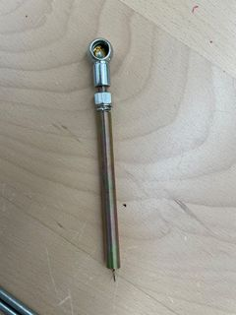

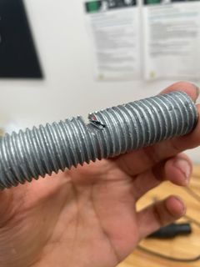2

3

4

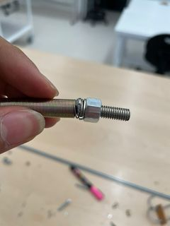

5

6

Replace with better pic of frame

7

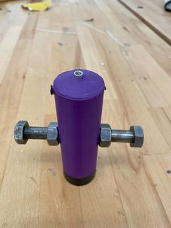

8

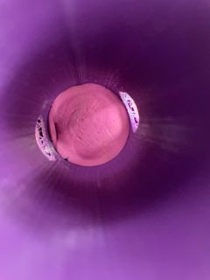

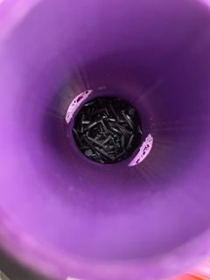9

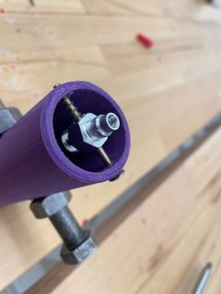10